GENDER BASED CYBERVIOLENCE : HARSH REALITY OF THE DIGITAL REALM
A.Rishika

ABSTRACT

In this new era of digitalisation when adolescent couples are eager to master the machine language, which can not only develop but also prolong gendered violence. This brutality has the potential to extinguish an individual’s flame or altogether life itself. In this article, the researcher would address the gendered violence in cyberspace across various age groups, institutions, workplace, and the safest space domestic cyberviolence encountered by many women today. This channel of learning can be used as a form of communication for betterment of the adolescent but also to exert a form of gender-based violence resulting in the downfall in their career, life. Everyone has related technology to their lives in every way possible, through love and hate, socially and culturally, economically, and financially and everyone has become so independent as they can express everything, they feel on the social networking sites, but the real question is, can they express everything? Because their activity is attacked by mostly the opposite gender, trying to drag them down alongside. There are few horrible tales to which not much acknowledgement is given by the society, in few cases not even by their loved ones. The research has been systemised to highlight and cover such pervasive problems and the results and recommendation have been provided according to the study.
Key words: gendered violence, cyber violence, gendered cyber violence, social network.

INTRODUCTION
Cyberviolence is a very intricate and an interconnected issue and many marginalised communities can be a target of cyberviolence. Technology’s development has made the cyberviolence both simpler and harsher. Though such development is required for Human’s to move forward as it is a part of day-to-day life but it also gives rise to numerous vulnerabilities which can lead to targeting of the sensitive communities. It has been defined as “the use of computer systems to cause, facilitate, or threaten violence against individuals that results in, or is likely to result in, physical, sexual, psychological or economic harm or suffering, and may include the exploitation of the individual’s circumstances, characteristics or vulnerabilities.”. In a way it can also be stated that the reason in rise in cybercrimes against the women can be the advancement in technological sector. The Cybersecurity Information Act,2000 which was later amended in 2008 is a compilation of a set of rules and regulations that govern the cybersecurity of India. Other sectors that draw relevance from this Act are Bharatiya Nyaya Sanhita (BNS), 2023, (also known as IPC,1860), Reserve Bank of India, 2018, The Companies Act, 2013. The main aim is to lookout for no discrepancy in the cybersecurity regulations and to ensure no arbitrariness to be found in the government and private corporations as well. While the measures are very well put forward but the misuse of the said regulations are also evident as of now.
Violence is any physical, sexual, psychological, verbal, or economic attitude and behaviour that is arbitrarily applied to an individual. Digital violence, one of the types of violence, has become quite common recently. To put forward the study, cyberviolence can be of various forms; cyber stalking, cyber bullying, digital dating-abuse, revenge pornography, hate speech and harassment, rape threats and death threats. Such sort of cybercrimes not only raise mental health awareness but, in a sense, physical health awareness too. As one longs to seek privacy through learning the machine language but the individual takes a while to realise how it could backfire on them.

Significance Of the Problem
Gender based cyber violence is predominantly occurring with the marginalised communities like LGBTQIA+, women and girls who have intersectional characteristics, i.e., women of colour, race. According to the Plan International’s 2020 Report, “Free to be Online” advocating for girls equality and empowerment has found that 58% of young girl and women have faced much more harassment online than on the streets. This report has further observed that most of the girls do not report on such as to protect themselves from further harassment due to lack of trust in such mechanisms. Such a harassment is not limited only to women due to usage of social networking sites but even the women journalists or any other women at a prominent position in a industry or representing a particular class are also subject to hate speech, violent threats and are abused by the opposite gender or even the same gender. It is not a cakewalk to identify the person abusing behind the device, the improvement in technology is used as a barrier not only to stay anonymous but also to get access to the privacy of the person being targeted. This is a clear violation of the civil rights of a woman and the reason could be that a cybercriminal assumes that such a behaviour towards a women is fair and tolerable. Such a repudiation in realising that women’s rights are being violated is a crime within itself. The reasons for which are rooted deep in harmful gender stereotypes and attitudes stemming from the continuous acceptance of patriarchal societal norms.

Difference between online and offline gender-based violence
Violence can be and is faced by any gender but it is faced by the women and young girls in immense proportion comparatively. As such, violence that is directed against a woman because she is a woman, and violence that affects women disproportionately, must be deemed gender-based violence (GBV). Gender is an essential aspect to discriminate or differentiate between individuals. It can be a powerful instrument for one and could derive weakness for another. In the stereotypical society, gender based violence can be faced by a woman, man, girl, boy, and anyone who falls under the queer umbrella, discrimination can be faced by one just for being who they are because the society would reject them at a stance. Offline gender based violence is a widespread problem to which more the legislature body provides solutions, much more problems are aroused. The thought should be given to the instance when a person faces such kind of violence offline, are there chances of them facing the same online as well? The Cyber Security Information Act, 2008 ensures preventions and reporting of the cyber threats and to follow the said procedures laid down in the Act. TheAct ensures all the cyber illegalities are to be reported but gendered cyber violence is in one of the most prevalent forms which is direct threats are posed or harassment. The Act includes a special team, Indian Computer Emergency Response Team (CERT) which stands at a very prominent position to respond to any cyber mis happenings and lays down a procedure to regulate and manage such situations. But the real question is, if these cybercrimes are been reported to the particular authority. Victims feel embarrassed, sad, afraid to use their smartphones, then felt guilty, betrayed, afraid of being imprisoned, depressed, disturbed thoughts, stressed and even traumatized. Women, as part of a vulnerable group, show a reluctance to speak in public about the forms of violence they experience in cyberspace when they meet their closest colleagues, authorities, or figures they trust. The legislature body is refusing to realise how difficult it is to even have a thought or a conversation about the harassment faced. Gender based violence (GBV) is evident on various online platforms, social networking websites, even on videogaming platforms. Female gender are not treated eminently on video gaming platforms, usually bullied, abused and discouraged about their gaming skills, which can lead to self doubt. Furthermore, Activists have also faced similar problem while advocating for the women in need. According to the research, United Nations came with young girls who attend educational institutions considerably below the age of 18, came up with an initiative to find out the Gender based violence among the young girls. 1.1 figure would demonstrate the mental and physical health awareness for the same.

- 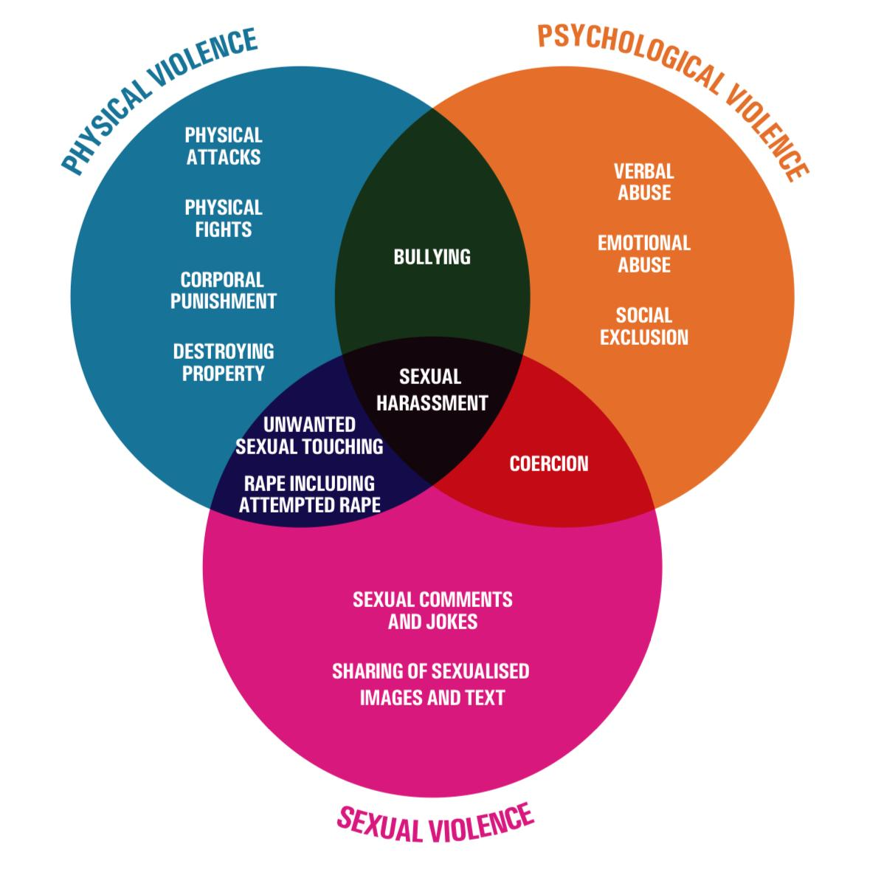

Source: UNESCO, 2019, and UNGEI and UNESCO, 2015 (United Nations Girls' Education Initiative, 2022).
India complies with many legislations in order to prevent such cybercrimes, such as, one of the main aims of the Information Technology Act,2000 is to make sure justice is provided to the person suffered through any offence by the usage of computer, S.66 of the ITA, 2000.
S.66 A was held unconstitutional by the Supreme Court of India, as it violated A.19(1), i.e., Freedom of speech and expression under the landmark case of Shreya Singhal v. Union Of India AIR 2015 SC 1523 - Legal Service India.

Women’s Resistance against cyberviolence
The legislations offered to combat the gender based cyber violence do not directly address the issue as such, they are framed to facilitate the problem of it. Though they are many welfare organisations that raise awareness and advocate for the gender based violence faced by the women, often refrain from expressing due to fear. The root cause of GBV is social inequality and injustice that has oppressed women’s basic, fundamental rights, and made them the norm.
Similarly, commentators told women to change their supervisors, fields, or jobs if the sexual treatment at work became too uncomfortable to bear. Third, many refused to recognize conduct as harmful due to an environment’s unique norms. Commentators suggested that workplace harassment involved a private arena with different expectations. In this view, sexual harassment was a perk for men to enjoy. In most of the cases, instead of following the assistance of Cyber Police, the women undergo mental health check-ups to maintain the privacy of the matter from the judgemental society. Many people are simply not able to take legal action themselves. This may be due to personal, financial or time issues, or they may not be aware of their rights or who to take their complaint to, or they may not have the capacity to advocate for themselves. However, recent research has highlighted that women are also using online platforms as a way of engaging, resisting and responding to harassment. The transformative potential of online media was once envisioned to significantly improve democratic governance through the increased potential for participation. Women are not laid back to having their safe cyber space. In case of any harassment, the women organisations and activists are approached to, help them expose the men on the same networking platforms. Whereby those who speak out about their victimisation are let down by the institutions from which they see redress The wide chasm between the law in theory and in practice raises questions relating to the appropriateness or, at the very least, the limits of devoting feminist energy to institutional and criminal justice investigatory and punitive mechanisms. Women who are victims of gender-based cyber violence can feel a sense of fairness, security and comfort as a fundamental individual right that perpetrators of cyber violence have taken away. Women are ought to be economically, socially and culturally empowered, and this is usually snatched away due to such gendered cyber violence. Promoting such empowerment, legal redressal, education, physical and mental health awareness training can help the victim to regain their will power and be themselves again.

The Role of Men
GBV – Gender based cyber violence can occur to both men and women but according to the research done by UN, it was revealed that 73% of women have faced GBV. But in the case of men though it is not much prevalent, but it should be addressed. Even the criminal legislations are usually penalising crimes against women and not aiming towards men as much. According to the social psychology of men, they are taught to be masculine and strong since their childhood, could result in boosting up their ego. This as well is a stereotypical flaw that is made a norm. Due to them representing their masculinity, men tend to demean women because they are women. When women engage in gender-valuing behaviour, they are often perceived as threatening the existing status and power structure of men. As a result, those that perceive this to be the case take actions that preserve the established status and power hierarchy by negatively stereotyping women as being incompetent. Moreover, Men usually in relation with a female, tend to take up the role of Machismo which leads to incompetency in their relation. The social psychology also revealed that after turning into adults, they tend to abuse women, so as, they were treated the same way as a child.
This has led to birth of a new term, Domestic Cyber Violence which is evident in the adolescent couples of the modern world. In a relation, when a man is not feeling self-sufficient or is not able to digest a woman’s achievements, he uses cyber violence to feel over-powered against her, through revenge pornography, cyber-bullying, harassing or threatening her on a social networking website. The first case of its kind was of State of West Bengal V. Animesh Boxi .
He was tried for Revenge pornography against his former girlfriend and the penalties were complied under Indian Penal Code (BNS) S.354A (Sexual Harassment), 354C (Voyeurism), 354D(Stalking) and 509 (Criminal Intimidation) and also the Information Technology Act, S.66C (Identity Theft), 66E (Violation of Privacy), and S.67 and S.67A (Transmitting obscene material online). In this sense, prevention efforts should be directed to both victims and perpetrators and consider the double role developed for some individuals, focusing on the impact that their own behaviours could have on their partner’s behaviours.

Conclusion
Gender based cyber violence is a complex structure of cultural stereotypes and advanced technology. This issue needs to be addressed with better implementation of laws and though there are cyberlaws, the laws should be designed in such a fashion to keep up with the advancement of technology. And such laws can be drafted with the help of professionals in the field of technology and ai, lawyers can help with the aspect of harassment. There should be stricter penalties in society to be compatible with the transforming gender roles. Revolution does bring change, which is not much evident in the beginning but there is always chance for betterment with time. As technology has become such an integral part of our lives, it cannot be ignored but if the problems arise from it, solutions can too. Gendered cyber violence exists in every cyberspace, one can never predict about privacy breaching matters. It all lies in the patriarchal attitude that thinks a woman blowing horns about her success is a threat to their masculinity. It has been turned into another battlefield where women have to fight for their basic rights which are being snatched to satisfy another’s ego. Only through clear confrontation, one can achieve peace. By advocating and becoming the voice of a GBV victim, by education, awareness programmes, and instead of educating women about the problem’s of women, initiatives to educate men about women should be taken, only then a change can appear. A commitment must be made to widen and reframe discussions of online harassment, and in doing so acknowledge diversity of experience.

Eugenia Dorokhova, hvale vale, Vasilika Laci, Aida Mahmutovic, Enhancing Cybersecurity Governance in the Western Balkans, GCSSG (DCAF), 5-55(2021) https://www.researchgate.net/publication/352553440
Duman, Meral Calis Digital Violence and Women: Systematisation of Researchs and Suggestions for Future Research, AUJFE, 359-398(2023) https://www.researchgate.net/publication/374157310_DIGITAL_VIOLENCE_AND_WOMEN_SYSTEMATIZATION_OF_RESEARCHS_AND_SUGGESTIONS_FOR_FUTURE_RESEARCH
Eugenia Dorokhova, hvale vale, Vasilika Laci, Aida Mahmutovic, Enhancing Cybersecurity Governance in the Western Balkans, GCSSG (DCAF), 5-55(2021) https://www.researchgate.net/publication/352553440
Eugenia Dorokhova, hvale vale, Vasilika Laci, Aida Mahmutovic, Enhancing Cybersecurity Governance in the Western Balkans, GCSSG (DCAF), 5-55(2021) https://www.researchgate.net/publication/352553440
Himawati, Yudithia, Hadiyanto Abdul Rachim, and Budi Muhamad Taftazani, Women Victims on Gender Based Cyber Violence From The Perspective of Person in Environment, MJP,ADJ 75-87 (2024) https://ejournal.uin-suska.ac.id/index.php/marwah/article/view/21313
Citron, Danielle K. , Law's Expressive Value in Combating Cyber Gender Has value in Combating Cyber Gender Harassment MLR 373-416 (2009) https://scholarship.law.bu.edu/faculty_scholarship/612
Deepa Sethi, Sanchita Gathak, Mitigating Cyber Sexual Harassment: An Insight from India, ATSSR, 34 - 43, (2018) https://core.ac.uk/download/pdf/230164011.pdf
Laura Vitis, Fairleigh Gilmour, Dick pics on blast: A woman’s resistance to online sexual harassment using humour, art and Instagram, CMC, 1-21, (2016) https://journals.sagepub.com/doi/abs/10.1177/1741659016652445
Sundari Anitha, Susan Marine, Ruth Lewis, Feminist responses to sexual harassment in academia: Voice, solidarity and resistance through online activism, JGBV, 1-28 (2020) https://bristoluniversitypressdigital.com/view/journals/jgbv/4/1/article-p9.xml
Himawati, Yudithia, Hadiyanto Abdul Rachim, and Budi Muhamad Taftazani, Women Victims on Gender Based Cyber Violence From The Perspective of Person in Environment, MJP,ADJ 75-87 (2024) https://ejournal.uin-suska.ac.id/index.php/marwah/article/view/21313
Jennifer D. Rubin, Lindsay Blackwell, Terri D. Conley Fragile Masculinity: Men, Gender and Online Harassment, 2020CHI-CHFCS, 1-14(2020) https://dl.acm.org/doi/abs/10.1145/3313831.3376645
Fernandez-Gonzalez, L., Calvete, E., Orue,I, Adolescent Dating Violence Stability and Mutuality: A 4-Year Longitudinal Study, JIV 2012-2032 (2020) https://journals.sagepub.com/doi/abs/10.1177/0886260517699953
Hackworth Lucy, Limitations of “Just Gender”: The Need for an Intersectional Reframing of Online Harassment Discourse and Research MMGTH, 51-70, (2018) https://link.springer.com/chapter/10.1007/978-3-319-72917-6_3

