EUTHANASIA
INTRODUCTION:
Euthanasia or also known as Mercy Killing is the term that is given to the terminating of a person’s life that will end the pain and suffering.¹ The term "euthanasia" originates from Greek, combining 'eu,' meaning 'good,' and 'thanatos,' meaning 'death,' thus translating to 'good death.' Widely recognized as 'mercy killing,' it's legally and medically described as the deliberate termination of an individual's life due to incurable suffering, typically in cases of agonizing illness. In simpler terms, euthanasia refers to purposeful actions or omissions that end the life of someone seen as enduring a life not worth living. There are mainly two kinds of Euthanasia, namely Active and Passive Euthanasia
HISTORY:
In the early 17th century, the term "euthanasia" was coined by the English philosopher Sir Francis Bacon. Originating from the Greek words "eu," translating to "good," and "thanatos," meaning "death," the term initially denoted a merciful or painless death.
The historical trajectory of euthanasia reveals its roots in Francis Bacon's work, where he introduced the term, distinguishing between internal (soul preparation) and external (painless end-of-life) aspects. This notion resurfaced in the 18th century with a focus on a gentle death sans agony. Karl Friedrich Heinrich Marx later advocated for alleviating death's suffering using medical aid, separating spiritual care from medical treatment. Despite opposition from Judeo-Christian traditions, voices supporting euthanasia emerged, like John Donne's in 1624.
The mid-1800s witnessed morphine and chloroform's use to ease death pains, though not for hastening death. Samuel Williams' 1870 proposal at the Birmingham Speculative Club sparked the modern euthanasia debate, advocating for conscious hastening of death using chloroform upon a terminally ill patient's request. This viewpoint gained traction through influential figures like Lionel Tollemache and Annie Besant.
The United States saw early legislative attempts in Ohio and Iowa in 1906 to legalize euthanasia under specific conditions, which generated significant debate but did not pass. The discussion waned until resurfacing in the 1930s in the UK. The movement in the US intertwined with the Gilded Age and the emergence of modern hospitals.
In the 1930s, the Voluntary Euthanasia Legalization Society was formed in the UK, while Nazi Germany's T4 program distorted euthanasia into a state-sponsored genocide. Post-war, the term "euthanasia" took on a distinct connotation contrasting with the Nazi program. In 1949, a New York petition to legalize euthanasia faced opposition from Catholic leaders, igniting broader tensions between the Euthanasia Society and the Catholic Church on societal issues.
DIFFERNCE BETWEEN ACTIVE & PASSIVE EUTHANASIA:
Usually, a physician's intention in euthanasia is compassionate, aimed at ending suffering. Physicians typically perform euthanasia, categorized as either "active" or "passive." Active euthanasia involves a deliberate action by a physician to terminate a patient's life, while passive euthanasia relates to refraining from or stopping treatment crucial for sustaining life. Active euthanasia has three types: voluntary, where the patient requests it; involuntary (also termed "mercy killing"), where a patient's life is ended without their request to alleviate suffering; and nonvoluntary, conducted without the patient's consent due to their incapacitation. Theoretical or ethical disparities between euthanasia and PAS may seem subtle, but practical differences can be notable. While both are distinct legally and ethically from administering high-dose pain relief that might hasten death (known as the rule of double effect) or withdrawing life support, the discrepancy lies in intent.
SUPPORT OF EUTHANASIA:
- Diminsing quality of Life
When a terminally ill patient's quality of life deteriorates to the extent that the only way to alleviate their suffering is through death, ethical considerations come into play. As the life of a terminally ill patient is prolonged through artificial means their conditions worsens both mentally and physically, when given more time where there is no scope of recovery only leads to financial and emotional strain on family and friends of the patient.
- Encourages organ transplant
Allowing euthanasia for terminally ill patients presents an opportunity to promote organ donation, thereby assisting numerous individuals with organ failure who are awaiting transplantation. Euthanasia not only grants the 'Right to die' for the terminally ill but also upholds the 'Right to life' for patients in need of organs
- No misuse of legalization in Organ & Netherlands
Even after legislation of both euthanasia and PSA only a very small minority of deaths. The most recent data from Oregon shows that just 9 in 10 000 deaths (0.09%) occur by legal physician assisted suicide. In the Netherlands, even after 20 years of practice and including the cases of involuntary euthanasia that lack contemporaneous consent from the patient and violate the safeguards, just 3.4% of all deaths are by euthanasia and physician assisted suicide. These data mean that in Oregon over 99.9% of all deaths and in the Netherlands over 96% occur without the intentional active ending of a life. It is true that about three times as many patients in the Netherlands inquire about and ask for euthanasia but do not die by this intervention. Even including these patients, euthanasia and physician assisted suicide play no part in the dying process of 90% of dying people.²
AGAINST EUTHANASIA:
- Opposite of Hippocratic Oath
The medical field is rooted in the intention to heal and prolong life. This principle finds its strongest expression in the Hippocratic Oath, where it's stated, “I will prescribe regimens for the good of my patients according to my ability and judgment and never do harm to anyone. To please no one will I prescribe a deadly drug, nor give advice that may cause their death.” Consequently, the prospect that a physician might actively expedite a patient's death - someone whom the physician has been ostensibly treating to enhance and lengthen life - goes against the core principle of the medical profession.
- Baises of Physician granting such request
An even more concerning scenario is that healthcare providers might propose euthanasia as an option because providing sufficient palliative care - the alternative - is either too expensive or challenging to access.
- Can be pressurised by family
Individuals from lower socioeconomic backgrounds or marginalized groups might feel "coerced," whether overtly or indirectly, into considering euthanasia as a solution to the challenges posed by their illness. Relatives might subtly imply that since death is inevitable, an earlier passing would be more favourable, given the social and financial strains involved in caring for terminally ill family members.

INTERNATIONAL SCENARIO
GUIDELINES FOR EUTHANASIA ACROSS THE WORLD:
There are various countries across the world where Euthanasia is legalized such as Netherlands, Canada, Australia etc. Most of these have certain common guidelines,
These criteria encompass:
(1) a patient's voluntary request for aid in dying,
(2) confirmation of a terminal illness, and
(3) detailed documentation by the primary physician justifying the request and outlining efforts to enhance the patient's care.
Proposed guidelines consistently emphasize the essential inclusion of psychiatric evaluation in assessing a patient's request for Euthanasia. Wherever Euthanasia is legal, mental health professionals hold a crucial role in evaluating end-of-life patients seeking an end to their lives. Some regions even mandate psychiatric assessment as a prerequisite before granting permission for Euthanasia.
INTERNATIONAL PERSPECTIVE
- USA
In United States, other than the state of Oregon, there hasn't been much movement towards legalizing euthanasia or physician-assisted suicide following the 1997 Supreme Court decision. In fact, in the last five years, 10 states have passed legislation explicitly prohibiting euthanasia or physician-assisted suicide, with bills awaiting decisions in five additional states. The public sentiment against these practices has been notable as well.
- GERMANY
Before 2020, section 271 of the German criminal code created significant barriers to assisted suicide. It stated that aiding someone in ending their own life could result in a jail sentence of up to three years. This law was primarily designed to prevent associations that supported assisted suicide by collecting funds from their members. However, since the 2020 judgment, these associations have been functioning without legal repercussions in Germany. They now openly provide services such as accompanied suicide or assistance in arranging medical aid for individuals seeking to end their lives.
Actively administering a fatal drug to another person, however, is and remains illegal. Such assistance in dying, sometimes referred to as voluntary euthanasia, remains prohibited in Germany, where the concept is seen to hark back to the time of the Nazi regime, where thousands of disabled people were killed in a program of mass murder by involuntary euthanasia.²
- UNITED KINGDOM
Under the Mental Capacity Act UK (2005), ‘advance decisions’ give a person the right to make a decision to refuse healthcare treatment in advance, including in situations where this would result in their death. Advance decisions are legally binding and any person who withholds or withdraws treatment in accordance with a valid and applicable advance decision will not incur liability. The UK Act also allows a person to appoint an agent to act on their behalf in the event that they lose capacity in the future, in the form of a ‘lasting power of attorney’. The attorney can be expressly authorised to give or refuse consent to medical treatment, including life-sustaining treatment.
- SPAIN
As of June 25, 2021, Spain legalized euthanasia through the enactment of the Organic Law for the Regulation of Euthanasia, which became effective three months after its publication in the Official State Gazette. This law permits euthanasia for individuals meeting specific criteria: they must be Spanish nationals, legal residents, or hold a registration certificate indicating a stay in Spanish territory exceeding 12 months to qualify for the procedure. However, minors are excluded from this legalized scheme and cannot access euthanasia under these regulations
- NETHERLANDS
in the Netherlands, physician-assisted suicide (PAS) and euthanasia have been part of regular medical practice for over 20 years. The country's current status regarding euthanasia was established in 1984 following a decision by the Dutch Supreme Court, which outlined specific conditions for the practice such as patient's request for PAS must be voluntary, suffering should be unbearable and all other measures are exhausted.
INDIAN PERSPECTIVE
RELIGIOUS PERSECTIVE:
The arrival of the Common Era marked a significant challenge for euthanasia in religious teachings such as Christianity and Judaism. Christianity, emphasizing life as a divine gift, encourages living it until its natural end. Similarly, Islam opposes euthanasia, considering life sacred and solely determined by Allah's will.
Hinduism presents a complex perspective. Its scriptures, spanning Srutis, Smritis, Vedas, Upanishads, Puranas, Gita, Mahabharata, and Ramayana, guide moral standards, duties, and principles. Hinduism, while seemingly advocating self-liberation, discusses self-liberation during incurable illness, as found in the Manusmriti. Central themes like Dharma, Arth, Karma, and Moksha emphasize attaining the ultimate goal of liberation from samsara, the cycle of birth, life, death, and rebirth.Hinduism views death as the soul's departure from the body to embark on a new cycle of life. Therefore, Hinduism doesn't necessarily condemn self-choice in specific situations. Stories of figures like Lord Rama, Lakshmana, and Lord Mahavir illustrate instances like Jal Samadhi and seeking death. Prayopavesa, fasting unto death, was practiced by Hindu leader Satguru Sivaya Subramuniyaswami in 2001, within certain limitations. According to Hindu beliefs, one may pursue liberation from samsara only after fulfilling life's aims. Texts like Vedas suggest that a terminally ill person with no chance of recovery may choose death. Similarly, Buddhism, originating from Siddhartha Gautama, focuses on liberation from samsara as life's ultimate goal. Jainism, emerging around the same time, also stresses rebirth and ultimate liberation.
Tibetan Buddhists, who view death as a process rather than an event, might assert that the spirit has not yet finished with the physical body. For them, thukdam begins with a “clear light” meditation that allows the mind to gradually unspool, eventually dissipating into a state of universal consciousness no longer attached to the body. Only at that time is the body free to die.
RIGHT TO DIE UNDER ARTICLE 21:
Constitution of India has given certain fundamental rights to citizens of India under part three, one of those rights is Article 21 namely, right to life. Article 21 reads as follows Protection of life and personal liberty No person shall be deprived of his life or personal liberty except according to procedure established by law. Thus, this article ensures personal liberty of an individual. The pivotal case of Maneka Gandhi vs. Union of India (1978) altered the landscape and notably broadened the scope of the interpretation of "personal liberty" outlined in Article 21 of the Constitution of India. In this instance, the court underscored that the right to life encompasses more than mere physical existence; it encompasses the right to live with dignity. The crucial aspect of the judgment lay in the interconnection between the provisions of Articles 19, 14, and 21.
In the case of P. Rathinam v. Union of India (1994), a Division Bench of the Supreme Court supported the decision of the Bombay High Court in the Maruti Sripati Dubal case, asserting that under Article 21, the right to life includes the right to die. This led to the declaration of Section 309 of the Indian Penal Code, which addresses attempts to commit suicide, as unconstitutional.
However, the matter resurfaced in the Gian Kaur v. State of Punjab (1996). Here, a five-judge Constitutional Bench of the Supreme Court overturned the decision in P. Rathinam's case. The court held that the Right to Life under Article 21 of the Constitution does not encompass the Right to die or the Right to be killed. It emphasized that the true meaning of 'life' in Article 21 involves life with human dignity. Any element that contributes to dignified life may be included within it, but not that which terminates it. The 'Right to Die,' if it exists, is fundamentally contradictory to the Right to Life, as death conflicts with life itself.
CASE LAWS:
- Gian Kaur v Union of India
In this case, constitutionality of Section 306 of IPC was challenged by Gian kaur and her husband by stating that this section of IPC is violative of article 21, rather right to die should be included in Article 21 and thus anyone assisting in enforcing this right should not be punished under Section 306. The Supreme Court reconsidered its earlier decision on suicide and held that “Abetment of suicide (IPC Sec 306) and attempt to suicide (IPC Sec 309) are two distinct offences, hence Section 306 can survive independent of Section 309. It has also clearly stated that a person attempts suicide in a depression, and hence he needs help, rather than punishment. Therefore, the Supreme Court has recommended to Parliament to consider the feasibility of deleting Section 309 from the Indian Penal Code.”

- Aruna Shanbag v Union of India
Aruna was a nurse who was assaulted by a ward boy in the hospital basement. He strangled her by a dog chain, leading to her being in Persistent Vegetative State (PVS) for next 41 years and was living on mashed potatoes. Her friend working at the same hospital had filed a petition before the Supreme Court asking it to direct the hospital to stop feeding the her and allow her to die peacefully. This was a landmark judgment as the court allowed passive euthanasia by withdrawing her food and water supply and let her take natural course of death.

- Common Cause v Union of India (2018)

In the year 2002, a registered society named Common Cause initiated a movement regarding grating euthanasia to terminally ill patients by writing letters to ministry of law & justice, health & family welfare and company as well as state governments. In 2005 they approached S.C under article 32 i.e., extensive original jurisdiction, requesting court to issue directions to central government and as an alternative they sought guidelines to regulate the same by appointing an expert committee who can analyze every aspect of this matter to decide the same. They argued that terminally ill patients should be given a right to shorten their suffering and not prolong the inevitable for a greater period of time. Thus, on march 8,2018 S.C held that right to die is a fundamental right and advanced directives to be used to regulate the procedure for the same. It was also held that right to privacy, bodily autonomy and freedom of choice are a necessity for human autonomy and dignity. In this case right to privacy of the individual with respect to bodily autonomy was held higher than state interest.

- COMMON CAUSE V UNION OF INDIA (2023)

Sc ordered to modify the guidelines to make this procedure less cumbersome and more inclusive. While the requirement of setting up two medical boards – one primary and another review to examine medical condition of the patient has been retained, the SC has done away with rule mandating that the district collector set up the review board. Both courts will be constituted by hospital. Review board must consist one nominee doctor and district medical officer. Sc also simplified the process of making a living will as earlier rule stipulated that a living will have to be made in the presence of two attesting witnesses and countersigned by the jurisdictional JMFC, the new order says such a will can be attested by notary or a gazette rank officer. Earlier there was no prescribed period of time for medical board to give their opinion but now The medical board must take decision on such cases within 48 hours. The court also agreed with the petition that there was no need to involve JMFC in the process of preparation of the will.

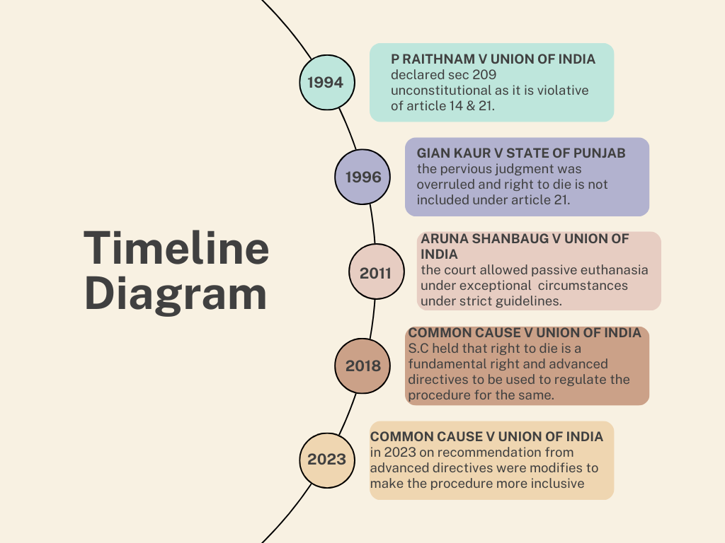

Euthanasia, Black’s Law Dictionary,2nd Edition.
2. Lisa Hanel, Assisted suicide: Germany weighs autonomy and ethics, Made for Minds, (Nov. 20, 2023,09:29pm)
Maneka Gandhi v Union of India, [ AIR 1978 SC 597]
P. Rathinam v. Union of India, (1994) 3 SCC 394
Gian Kaur v. State of Punjab, (1996) 2 SCC 648
Aruna Ramachandra Shanbaug v. Union of India, (2011) 4 SCC 454
Common Cause v. Union of India, (2018) 5 SCC 1

