HARMONISING PERSONAL LAWS: UNIFORM CIVIL CODE
Mili Khatri, a Third-year B.A. LL.B. law student at Jai Narain Vyas University in Jodhpur is the author of this article.
Being a diversified country, India has a wide variety of personal laws. These laws also differ based on regional or sect-specific norms and practices. While some of them are codified, others are not. Numerous of these personal laws contain discriminatory practices, lacunas or loopholes. There are challenges regarding how these personal laws are applied in Indian courts. As a result, there is always a conflict as to which legislation will take precedence.
Article 44 under part IV of the constitution has a provision for the Uniform Civil Code as a Directive Principle of State Policy, which requires the state to secure for the citizens a uniform civil code throughout the territory of India. Applying “one nation, one law” is a long haul and challenging, necessitating a balanced and unbiased perspective. UCC could remedy these unfair practices and shortages, promoting equity and justice.
This article will thus focus on UCC's overall impact in India and gauge a better understanding of public perspective by analysing the data collected.

INTRODUCTION
India has various personal laws governing each religion. Also, there are numerous indigenous tribes spread across India, and each has its own set of customary personal laws governing adoption, divorce, inheritance, maintenance and child custody, which are given specific protection rather than exceptions under the sixth schedule of the constitution.
Personal law is the body of laws controlling interpersonal interactions and family-related issues, often referred to as family law or matrimonial law. Hindu, Christian, Islamic and Parsi Law are a few broad personal law sects in India. For instance, the Hindu Marriage Act of 1956 governs the Hindus, Sikhs, Jains, and Buddhists. The laws pertaining to Christianity regulate Christians, while Islamic Law governs Muslims, and the Parsi law is the body of law that governs India's Parsi Zoroastrian community.
UCC aims to create a common set of civil laws applicable to all citizens, regardless of religion, gender, personal beliefs, caste or sect.

METHODOLOGY: An E-survey was undertaken to investigate the research approach intended to determine public opinion about the Uniform Civil Code (UCC). The survey was created to gather information from diverse respondents, ensuring a comprehensive understanding of alternative viewpoints. The questionnaire consisted of carefully crafted questions.
The survey was disseminated on numerous platforms and social media platforms to reach a broad demographic. The survey was available for a specific amount of time. This approach resulted in 116 people participating in the survey and contributing insightful responses.
LIMITATIONS: It is critical to recognize this study’s methodology limitations. The sample may be representative of only a small fraction of the population as the survey was done online. Potentially there may have been biases introduced due to the distribution methods. However, multiple demographic groups were targeted to ensure a broad sample, and participation from people with different experiences and viewpoints was encouraged.
OBJECTIVE: The findings obtained from this research will help us gauge public sentiments and explore the potential benefits, challenges, and concerns associated with the UCC.
The survey response rate, broken down by age, gender, profession and religious affiliation and awareness of personal laws is shown in the graph below.
AGE GROUP: The age group of 15 to 25 constituted the highest number of respondents, accounting for 62.9% of the total participants. Ages 26- 35 constituted 23.3%, whereas age group 46-55 constituted 8.6% and ages 55 and above constituted 5.2% of the total respondents.
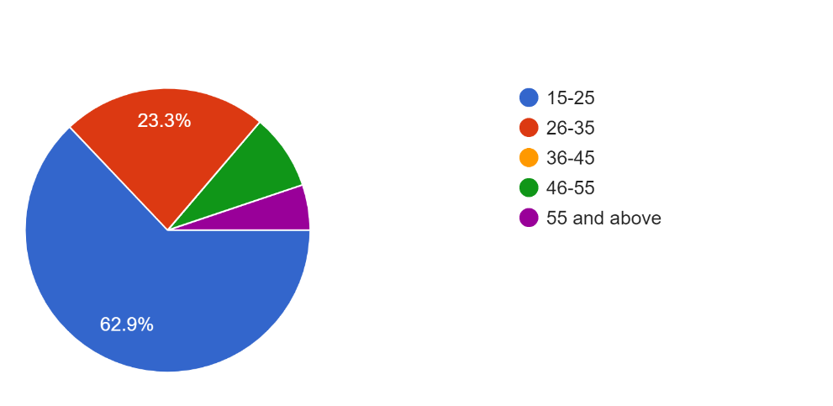

GENDER: The survey had a participation rate of 56.9% from males, 43.1% from females, and no respondents from other gender categories.
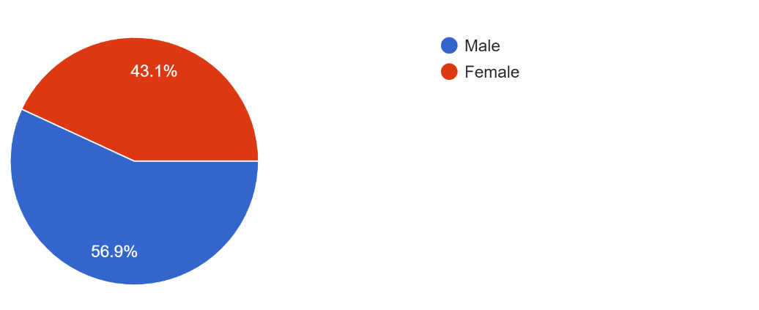

PROFESSION: The participation by students from non-legal backgrounds was 32.8%; students from legal backgrounds comprised 27.6%; legal professionals comprised 4.3%; self-employed comprised 14.7%; government employees 2.6%; and other professions comprised 18.0%.

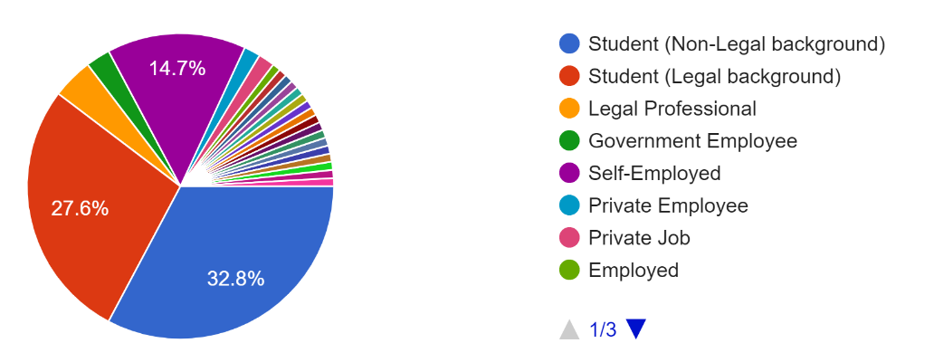

RELIGIOUS AFFILIATION: Among the respondents, 87.9% identified themselves as affiliated with Hinduism, 4.3% belonged to Jainism, 3.4% belonged to the Islamic religion, 1.7% identified as Christians, and 1.7% preferred not to disclose their religion.

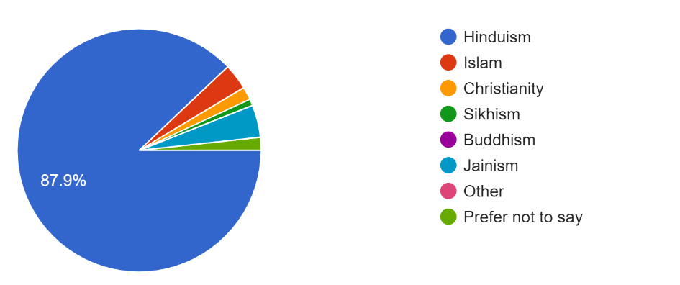
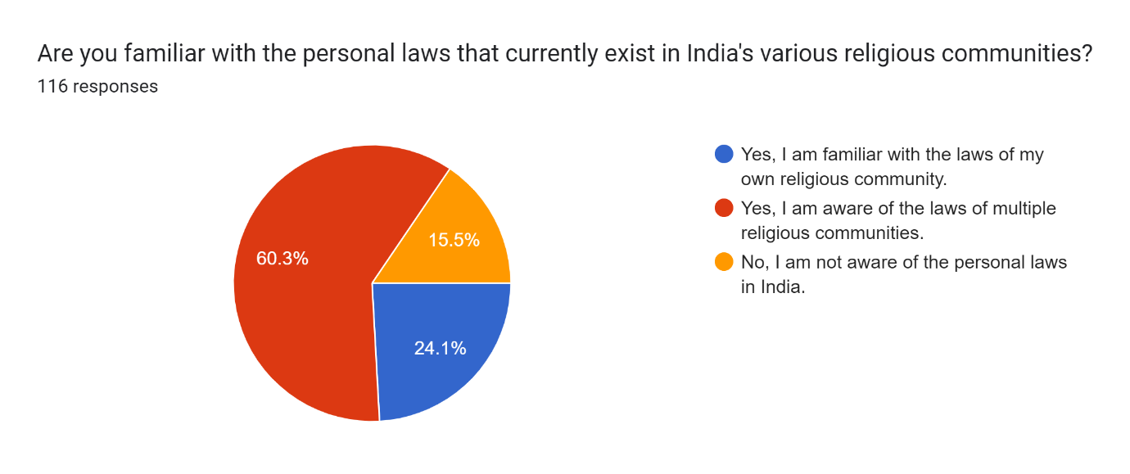
AWARENESS OF PERSONAL LAWS: Potentially there may be bias in this data as the respondents were mostly from legal backgrounds, so the majority of respondents, i.e., 60.3%, were aware of laws of multiple religious communities existing in India, whereas 24.1% were familiar with laws of their own religious community and 15.5% were not aware of personal laws in India.
The report by the Law Commission in 2018, titled Consultation Paper on ‘Reform of Family Law,’ examined various aspects related to personal laws but did not favour implementing a UCC in India during that time.
The report advocated removing discriminatory practices first in each religion in order to guarantee equality ‘within communities’ rather than equality ‘between communities’, as it believed that the social evils in each religion should not take protection in the name of religion as it would be a grave folly.
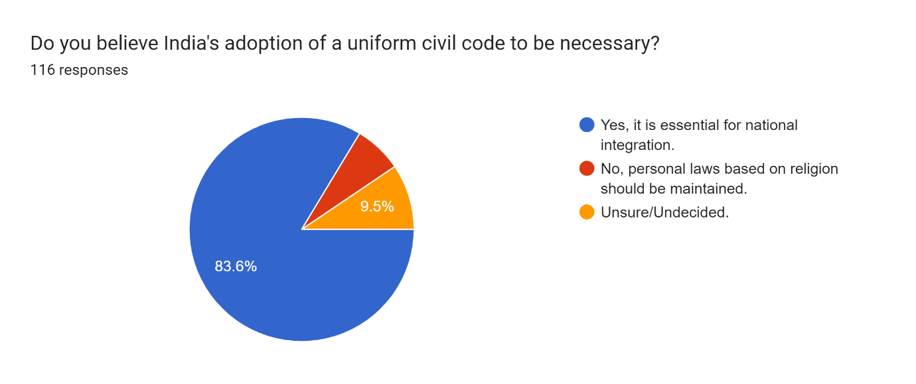
According to the survey, 94% of the total respondents, or the majority, were familiar with the term "UCC," whilst 6% were not. Additionally, it should be considered a limitation as most respondents to the poll were from tier 1 and 2 cities.
Among them, 83.6% believed that UCC is necessary for national integration. In comparison, 6.9% of the respondents had contrary opinions that personal laws based on religion should be maintained, and 9.5% were unsure or undecided about whether India's adoption of UCC is necessary.
Here are a few discriminatory practices in personal laws, also stated in the report of the law commission in 2018. Thereby, UCC could potentially be a remedy to remove such unfair practices, gaps, loopholes and uncertainty in the laws.
MARRIAGE AND DIVORCE
AGE OF CONSENT FOR MARRIAGE
Muslim law: Under Muslim Personal Law, which remains uncodified in India, recognizes the marriage of a minor who has attained puberty as valid, i.e., such persons who are still minor are eligible to get married.
The detrimental effects of child marriage, particularly on young girls, led to the attention of numerous medical research institutions and other organizations.
Child marriage is linked to early childbearing, obstetric complications, violence, and sexually transmitted infections, according to international organizations like the World Bank, the United Nations Population Fund (UNFPA), and the United Nations Children's Fund (UNICEF).
Additionally, it makes statutory and personal laws ambiguous thereby contradicting other laws.

POLYGAMY
It is an arrangement in which a male person has more than one wife, is one of the recognized practises in Islam. This principle conflicts with statutory law and transgresses fundamental constitutional norms, which is discriminatory conduct, especially towards women.
Besides the Muslim community, which has been granted the legal status of polygamy, it has been shown that Districts with a significant tribal presence tend to use this practice more frequently. The research showed that Scheduled Tribes (ST) people in India have the highest polygamy rates. These conducts reflect prejudice against women in general.
BIGAMY UPON CONVERSION
Hindu law: Despite it being clear that a converted spouse's subsequent marriage would not be recognized as legal if the former spouse continues to practise the faith in which the marriage was solemnized still such conversions take place.

MAINTENANCE
Muslim law: According to Section 3 of the Muslim Women (Protection of Rights on Divorce) Act of 1986, a Muslim divorced woman is entitled to reasonable and fair maintenance from her former husband within the period of iddat and, Section 4 states that if the woman is unable to support herself after the period of iddat, her parents and other relatives will be responsible for doing so in the order in which they will inherit her property, and if they are unable to do so, it would be the responsibility of the Waqf board to maintain her.
As a result, section 3 of the act limited Muslim women's right to divorce their husbands given that they are only liable for maintaining her during the iddat period.

Is the husband entitled to maintenance from the wife in personal laws?
If the husband can prove that he has no independent source of income, he is not entitled to seek maintenance pendente lite from his wife under Muslim, Christian, or even the Special Marriage Act. However, this is not the case with Hindu personal law.
The survey showed that a majority of respondents, i.e., 87.1%, believed that UCC would ensure equal rights for all individuals, whereas 4.3% believed that personal laws already address gender issues adequately, and 8.6% were unsure of or were of undecided opinions.
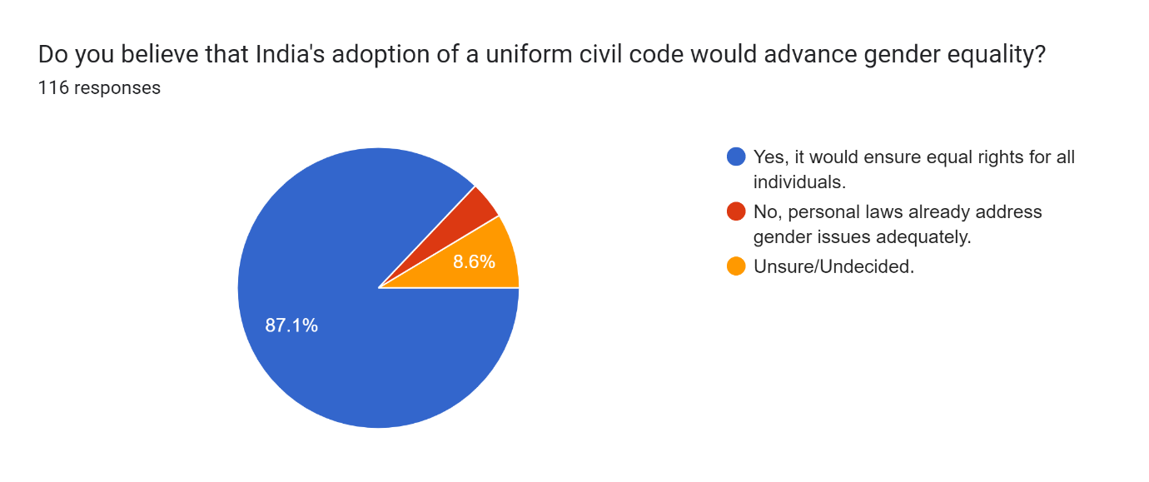
Thus, rules in the contemporary era should be equal for both men and women and, thereby, be gender-neutral.
HINDU MINORITY AND GUARDIANSHIP ACT, 1956: NATURAL GUARDIANS
Hindu law: The father is the natural guardian of minor legitimate children, sons, and daughters, according to section 6. Furthermore, it is only when he dies; mother could be the natural guardian. However, even if the father is alive, the mother is the child's natural guardian. While in certain legal systems, the husband is regarded as the wife's natural guardian.
While these provisions specify that if a child is illegitimate, the mother shall be the minor's natural guardian, the section's language looks as if the mothers are to be treated inferior to fathers. Mother is therefore judged unable to act as the child's guardian when the child is legitimate but capable when the child is illegitimate.
Therefore, these provisions infringe the equality doctrine found in Articles 14 and 15 of the Constitution.
Muslim law: As the rules are not specifically codified in Muslim law regarding custody and guardianship so, they are determined by the prevalent usages.
Guardianship in marriage(jabar): Muslim law empowers a father to impose status of marriage on his minor children and failing him the father’s father how highsoever as guardian in marriage. Thus, giving no right to the mother of the child.
Guardianship of a person: Although the father has the child's guardianship, the mother may have custody of the child. Granting him the authority to make any choice regarding the child's future. Since the mother is neither a legal nor a natural guardian, she is not permitted to sell her minor children's ownership interests in property or accept gifts on their behalf.
As partners in parenthood, both parents must have an equal voice in decisions affecting the well-being of their children. Guardianship must become a gender-neutral notion. A woman has often been recognised as a homemaker, and society imposes a duty on her to protect her children. However, she is not recognised as someone who could decide for her family's well-being. Men hold a vital role within households in the patriarchal society of India, giving them access to and control over all the resources. They, however, receive preferential treatment when it comes to care and guardianship matters. Although women are legally entitled to custody, men typically hold control positions, such as guardianship. This needs to be altered by providing equal footing to both parents.
Therefore, the mother should also be treated as the natural guardian of the minor.
ADOPTION
The Guardians and Wards Act of 1980: Islamic, Christian, Parsi, and some other personal laws do not recognise full adoption. No official system allows non-Hindus to adopt a child; instead, under the 1980 Guardian and Ward Act.
The Quranic rule states that the Sharia does not recognise adoption. In Islam, children born to legally married parents can have a relationship with their parents. Other than that tie cannot be established between adopted children and parents.
Similar to other personal laws like in Christian and Parsi law, there is no explicit statute governing adoption; nonetheless, adoption from an orphanage is permitted with court approval in accordance with the Guardians and Wards Act. However, there is still an absence in these particular statutes.

CHALLENGES IMPLEMENTING UCC
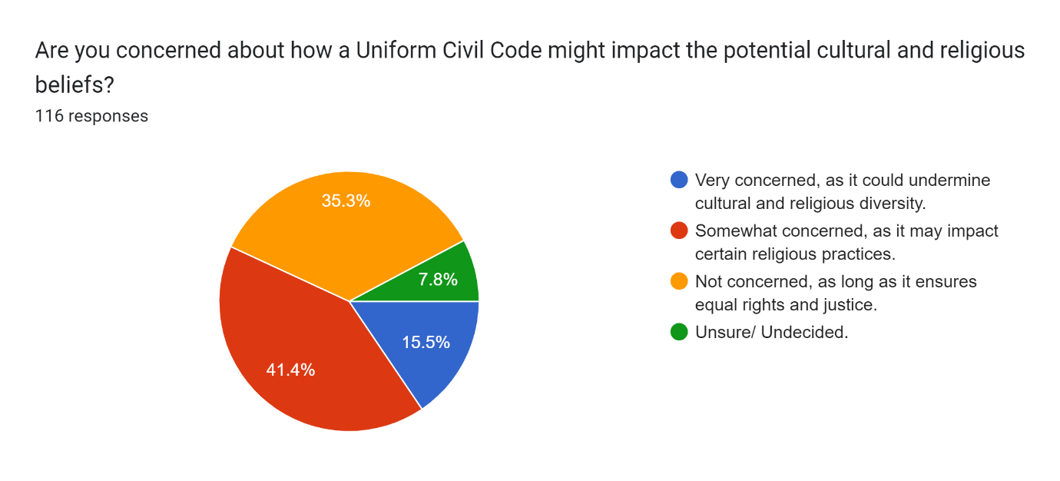
Most respondents, i.e., 41.4%, were concerned that a uniform civil code might somewhat impact certain religious practices. In comparison, 15.5% were highly concerned regarding the same, 35.3% were unconcerned as long as UCC could ensure equal rights and justice, and 7.8% of respondents had undecided opinions. The data shows that the government should develop a draft to uphold each religion's positive essential religious practices.

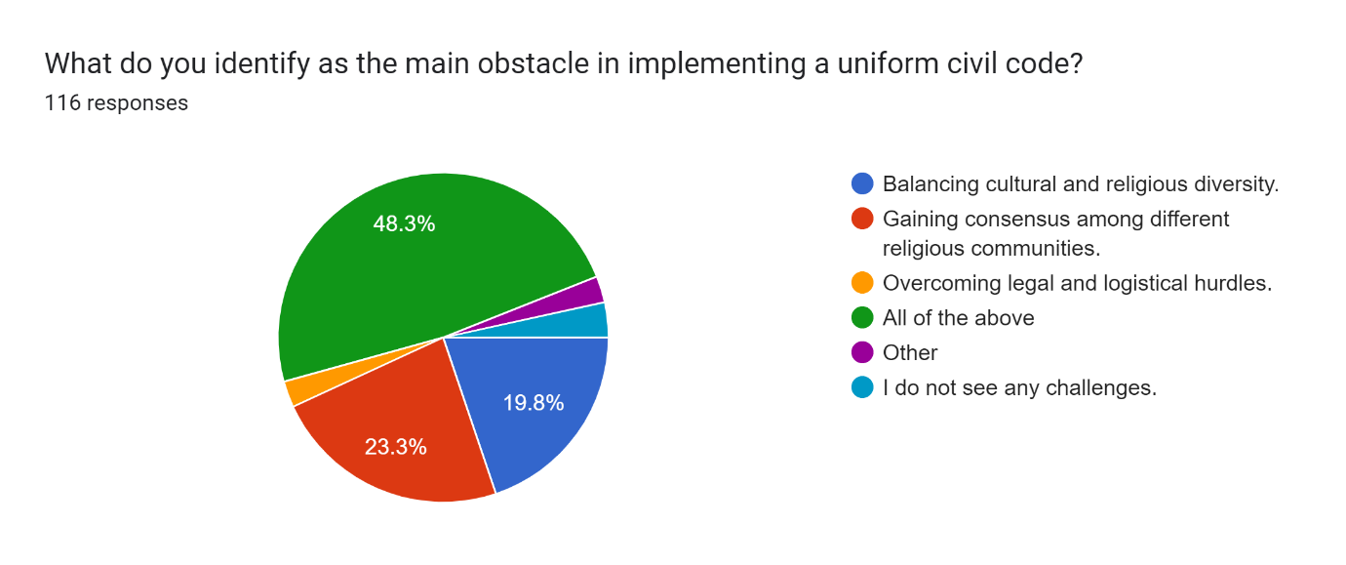
Balancing cultural and religious diversity, gaining consensus among different religious communities, and overcoming legal and logistical hurdles (2.6% of respondents thought it to be the main barrier, while 2.6% stated there were other barriers besides those cited, and 3.4% observed no difficulties in implementing UCC) are a few obstacles that need to be acknowledged while drafting a bill for UCC taking into account the religious sentiment of every community and thereby bringing experts from all communities and faith together and drawing from the best of their traditions and practices and thus, making them applicable for modern times.

BENEFITS OF IMPLEMENTING UCC
The implementation of UCC might ensure equal rights for all citizens, especially women, by preserving equality as enshrined in our constitution. It could also simplify the legal process as a common set of laws could remove ambiguity or uncertainty in laws, and uniformity does not mean that one will lose what is essential to one’s faith, practice, belief or tradition. It would only strengthen national integration and provide social cohesion respecting every religion as everyone would be treated equally without any discrimination.
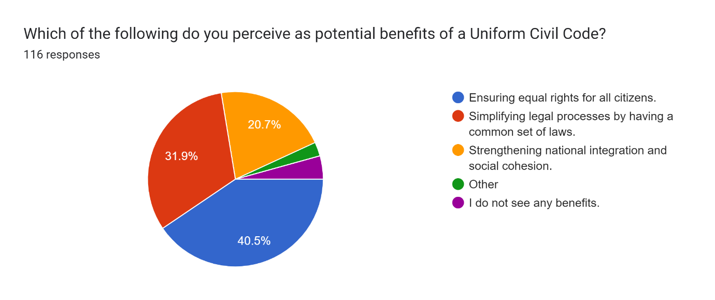
2.6% of the respondents observed other benefits than the one mentioned above, while 4.3% did not see any benefits with the implementation of UCC.

SURVEY FINDINGS: The aggregated result of the survey of the public sentiments to implement UCC in India was majorly supported, i.e., 80.2% of respondents supported the implementation of UCC in India, believing it to be critically important and wanted the government to take action in order to bring UCC as the need of an hour. Whereas, Only 8.6% of respondents thought personal laws should be preserved to respect differing beliefs and to preserve religious practices, and 11.2% of respondents were unsure or undecided about the issue.
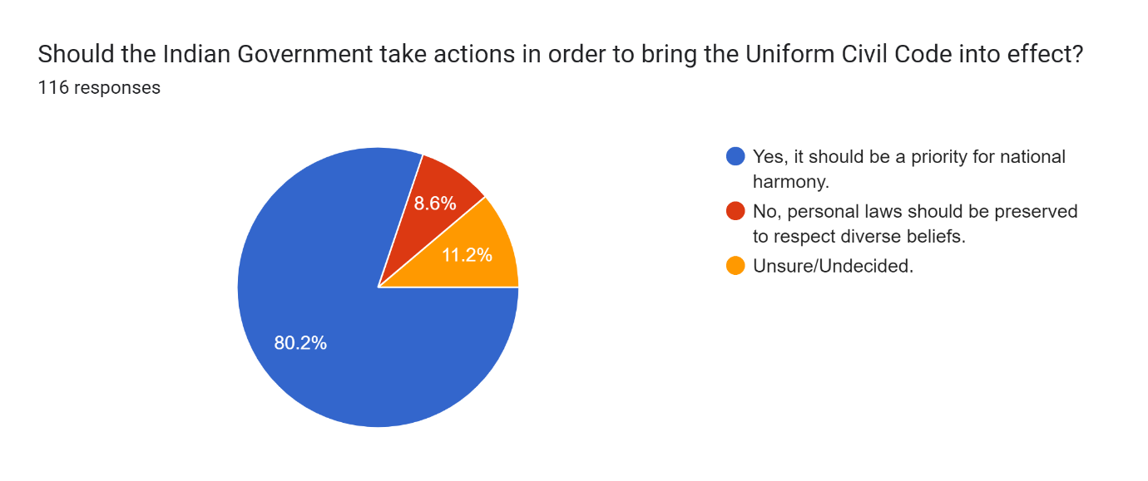
CONCLUSION
These provisions and customs in different personal laws indicate a need towards a common uniform code which could remove such discriminatory practices, ambiguity and uncertainty in these laws.
Though there are only a few instances of Muta marriage (where there is no limit to number of wives and also the husband is not bound to provide residence to Muta wife) or Misyar marriages among a particular Muslim community of India but still these practices deprive citizens of their basic fundamental rights. Similarly, Muslim men getting twice the share of the female while inheriting the deceased's property needs an alteration.
Also, In Hindu law, practices such as HUF (Hindu undivided family) for tax exemption should be abolished. It also remains unclear under what personal law such a case would be handled if property or maintenance was to be sought in cases where daughters were often disentitled from inheritance if they converted their religion after marriage to some other religion. So, such ambiguity and uncertainty remain in personal laws making it unclear which law takes precedence.
Even laws like the Special Marriage Act of 1954, which is regarded as a model law, have flaws in their provision; after a marriage is registered, a 30-day notice period is offered, allowing the couple's family the chance to oppose an inter-caste or inter-religious union. Therefore, UCC could defend such spouses by drafting a judicious law and making registration of marriages compulsory for each citizen, giving a married couple legal status. However, it will also provide protections for the wife and the husband if something goes erroneous, like in the case of bigamy or polygamy.
Contradictory opinions, such as "People who believe in the same constitution should be subject to the same laws regardless of their religious affiliation," were highlighted by the survey. While the opposing group were mainly of the view that " UCC will be beneficial for the country's future, but in a current climate of rising religious conflicts, bringing everyone together can be counterproductive because bias always creeps through, no matter how fair the rules are”. Thus, the other group disagreed.
Given the need for a blueprint or model draft, predicting how the UCC would change the current procedures used by various personal laws is challenging. Nevertheless, I genuinely believe that UCC is essential for addressing societal ills like inequalities based on gender as different aspects of current personal laws downside women. However, there are many obstacles in the way like a need to maintain positives from each personal law preserving cultural and religious diversity.
In conclusion, a committee comprising ministers, experts from all religions and personal law, members of the law commission, IAS officers, and other relevant authorities would be the best way to address the issue. However, adopting the best practices from each religion could win over those opposed to the implementation. Thus, meeting them and addressing their concerns could be a constructive way forward.

Law Commission of India, consultation report on “Reform of family law”, p.no.3 (31 August 2018)
Mulla’s Principles of Mohammedan Law Article 251(3) explains Puberty is presumed, in the absence of evidence, on completion of the age of fifteen.
Fan, S., Koski, A. The health consequences of child marriage: a systematic review of the evidence. BMC Public Health 22, 309 (2022). available at: https://doi.org/10.1186/s12889-022-12707-x (last visited on June 23rd June 2023)
Nikhil Rampal, “it’s not just Muslims who have multiple wives in India. But practice has declined across faiths”, The Print, May 18, 2023 available at: https://theprint.in/india/its-not-just-muslims-who-have-multiple-wives-in-india-but-practice-has-declined-across-faiths/1578799/
See Sarla Mudgal v/s Union of India AIR 1995 SC 1531
See Shah Bano Begum v. Mohammad Ahmed Khan, AIR 1985 SC 945.
The State shall not deny to any person equality before the law or the equal protection of the laws within the territory of India.
Article 15(1): The State shall not discriminate against any citizen on grounds only of religion, race, caste, sex, place of birth or any of them.
Adoption Laws in India, available at: https://vakilsearch.com/blog/adoption-laws-in-india/ (last visited 27th June’ 23)
A temporary marriage recognised only in Ithna Ashari school is a marriage for pleasure or enjoyment and is for a fixed period after specifying dower.
In misyar, the wife gives up her rights offered under the religion, including the right to have the husband living with her in the same house and providing her with necessary expenses.

